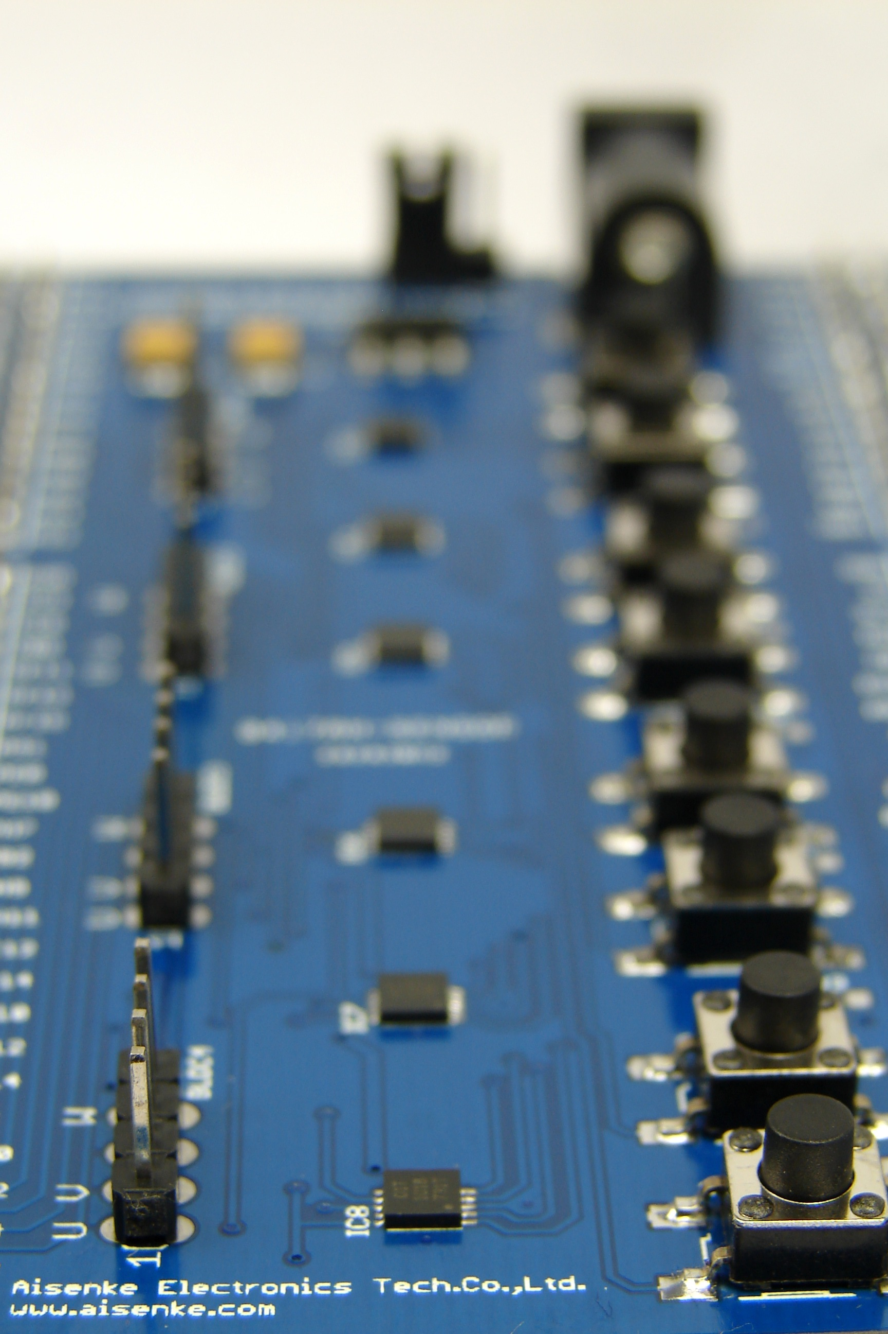

F4-DiscoverFree Kit Series

Chongqing Aisenke Electronic Technology Co.,Ltd.

Phone/Fax: +86-2363743515
Email: info@aisenke.com
USER MANUAL
BLDC Motor Extension Board

Version R1.0

UM-EB-0001

User Manual for BLDC Motor Extension Board R1.0

This user manual contains information on how to install and operate the BLDC motor extension board atop of F4-DiscoverFree kit.

First release, January 2013

Many designations used by manufacturers and vendors to distinguish their products are claimed as trademarks. Where those designations appear in this book, and the authors were aware of a trademark claim, the designations have been printed in all caps or initial caps. Any of the trademarks, service marks, collective marks, design rights or similar rights that are mentioned, used or cited in this user manual are the property of their respective owners. Their use here does not imply that you may use them for any other purpose other than for the same or a similar informational use under the CC-BY-SA licensing schemes. Unless otherwise stated, authors are neither endorsed by nor affiliated with any of the holders of any such rights and as such authors cannot grant any rights to use any otherwise protected materials. Your use of any such or similar incorporeal property is at your own risk.

Every effort has been made to ensure that this user manual is free from error or omissions. However, authors or their respective employees or agents, shall not accept responsibility for injury, loss or damage occasioned to any person acting or refraining from action as a result of material in this manual whether or not such injury, loss or damage is in any way due to any negligent act or omission, breach of duty or default on the part of authors or their respective employees or agents.

This user manual is released under the Creative Commons Attribution-ShareAlike 3.0 Unported License. For more details regarding your rights to use and redistribute this work, see http://creativecommons.org/licenses/by-sa/3.0/

Copyright © 2013 Chongqing Aisenke Electronic Technology Co.,Ltd. Some rights reserved. Unlimited permission to copy or use is hereby granted subject to inclusion of this copyright notice.

Nodino Robotics is a registered trademark of Aisenke Electronic Technology Co.,Ltd. For more information about this project and F4-DiscoverFree, visit us online at http://www.aisenke.com

Table of Contents
1 Introduction 6
2 Getting Started 7
2.1 System Setup 7
2.2 Hardware References 7
2.3 Software Requirements 10
2.3.1 PC Software 10
2.3.1.1 PuTTY Setup on Windows 10
2.3.1.2 PuTTY Setup on Ubuntu Linux 12
2.3.1.3 PuTTY Setup on Mac OS X 14
2.3.2 BLDC Firmware 15
2.3.3 FTDI Driver 16
3 Hardware References 17
3.1 Jumper SV5 17
3.2 DC 5V Socket 18
3.3 BLDC Motor Interface 18
3.4 Push Buttons 19
4 Command References 20
4.1 Motor Properties 20
4.1.1 position command 20
4.1.2 position_reset command 21
4.1.3 anchor command 21
4.1.4 anchor_set command 21
4.2 Controller Properties 22
4.2.1 bemf command 22
4.2.2 bemf_on command 22
4.2.3 bemf_off command 22
4.2.4 button command 22
4.2.5 button_on command 23
4.2.6 button_off command 23
4.3 BLDC Movement 23
4.3.1 direction command 23
4.3.2 step_cw [n] command 23
4.3.3 step_ccw [n] command 24
4.3.4 cw command 24
4.3.5 ccw command 24
4.3.6 stop command 24
5 Schematic 25
6 Revision History 26

Illustration Index
Illustration 1: BLDC Motor Extension Board from top view 6
Illustration 2: Hardware setup with a computer or laptop 7
Illustration 3: BLDC-MEB top component description 8
Illustration 4: BLDC-MEB bottom component description 9
Illustration 5: PuTTY Session setting on Windows 10
Illustration 6: PuTTY Terminal setting on Windows 11
Illustration 7: PuTTY Terminal Session is running on Windows 11
Illustration 8: PUTTY Session setting on Linux 12
Illustration 9: PuTTY Terminal setting on Linux 13
Illustration 10: PuTTY Terminal Session is running on Linux 13
Illustration 11: PuTTY Session setting on Mac OS X 14
Illustration 12: PuTTY Terminal setting on Mac OS X 15
Illustration 13: PuTTY Terminal Session is running on Mac OS X 15
Illustration 14: Jumper pin at 2 and 3, separating external power to USB power 17
Illustration 15: Jumper pin at 1 and 2, combining both external and USB power line 17
Illustration 16: Power supply connected to BLDC-MEB 18
Illustration 17: BLDC pins: U, V, N (not used) and W 19
Illustration 18: Programmable CW and CCW buttons 19
Illustration 19: BLDC help screen 20
Illustration 20: BLDC-MEB Schematic 25

Index of Tables
Table 1: Revision history 26

Introduction
Brushless DC (BLDC) Motor Extension Board (MEB) is powered by Allegro Microsystems' chips to drive four brushless DC motors at 3.3V with maximum amperage up to 400mA for each one. The driving method is square wave commutation with back EMF feedback reading, also known as sensor-less BLDC driving.
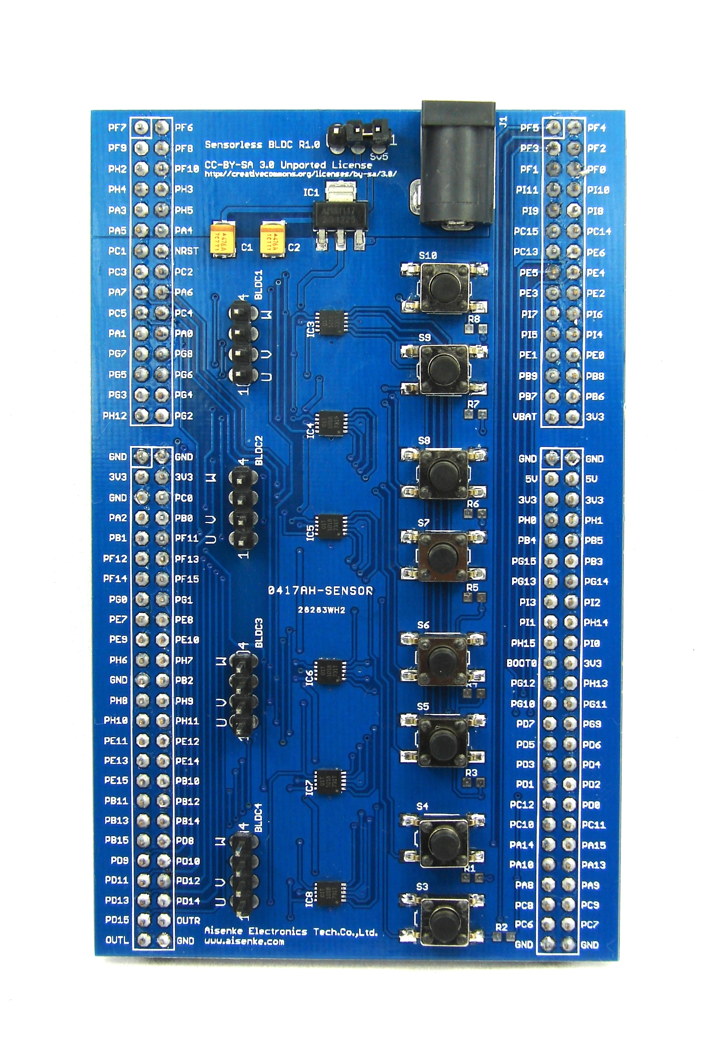Illustration 1: BLDC Motor Extension Board from top view
The extension board merely includes motor driver chips, push buttons as inputs and voltage regulator, to be used together with an F4-DiscoverFree development kit. There is no firmware required on the BLDC-MEB. However a firmware update is necessary on the F4-DiscoverFree board.
Motor pins assignment are compatible with Namiki brushless DC motors. However, it is easy to adapt to other brushless DC motors since U, V and W connectors are provided on the board as generic single row headers with standard 2.54mm pitch.

Getting Started

System Setup
The system setup you need to prepare should look similar to illustration 2 containing F4-DiscoverFree with BLDC-MEB, a computer and one to four brushless motors connected:
Illustration 2: Hardware setup with a computer or laptop
Detail hardware required to start developing application with BLDC-MEB are:
- F4-DiscoverFree R1.3 or later
- BLDC-MEB R1.0
- One BLDC motors with less than 400mA stall current
- One USB type A to mini B cable
- Computer running Windows, Linux or Mac OS X with one USB port
- Some wiring and soldering for motor interfacing

Hardware References
Detail hardware references can be found on page 17. Figure 3 and figure 4 briefly explain all interfaces available on top and bottom layers of BLDC-MEB:
- JP SV5 is a three-pins headers with a jumper to separate or combine the external power supply to the USB power line.
- DC 5V is an external power supply socket. Add an external power supply if the stall current of all motors combined exceed 400 mA.
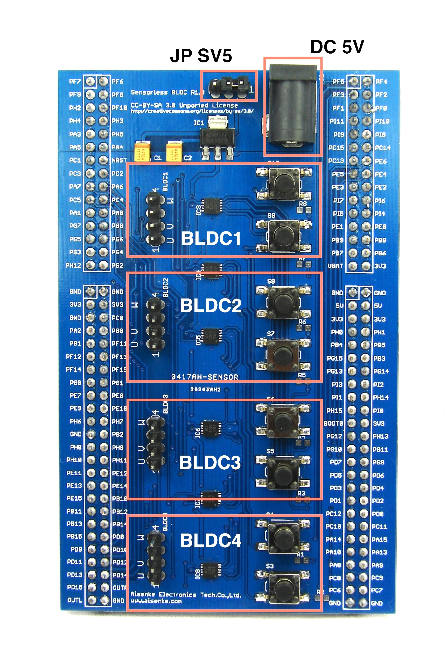Illustration 3: BLDC-MEB top component description
- BLDC1 area contains a four-pins header as output to motor and two programmable push buttons for manual control.
- BLDC2 area contains a four-pins header as output to motor and two programmable push buttons for manual control.
- BLDC3 area contains a four-pins header as output to motor and two programmable push buttons for manual control.
- BLDC4 area contains a four-pins header as output to motor and two programmable push buttons for manual control.
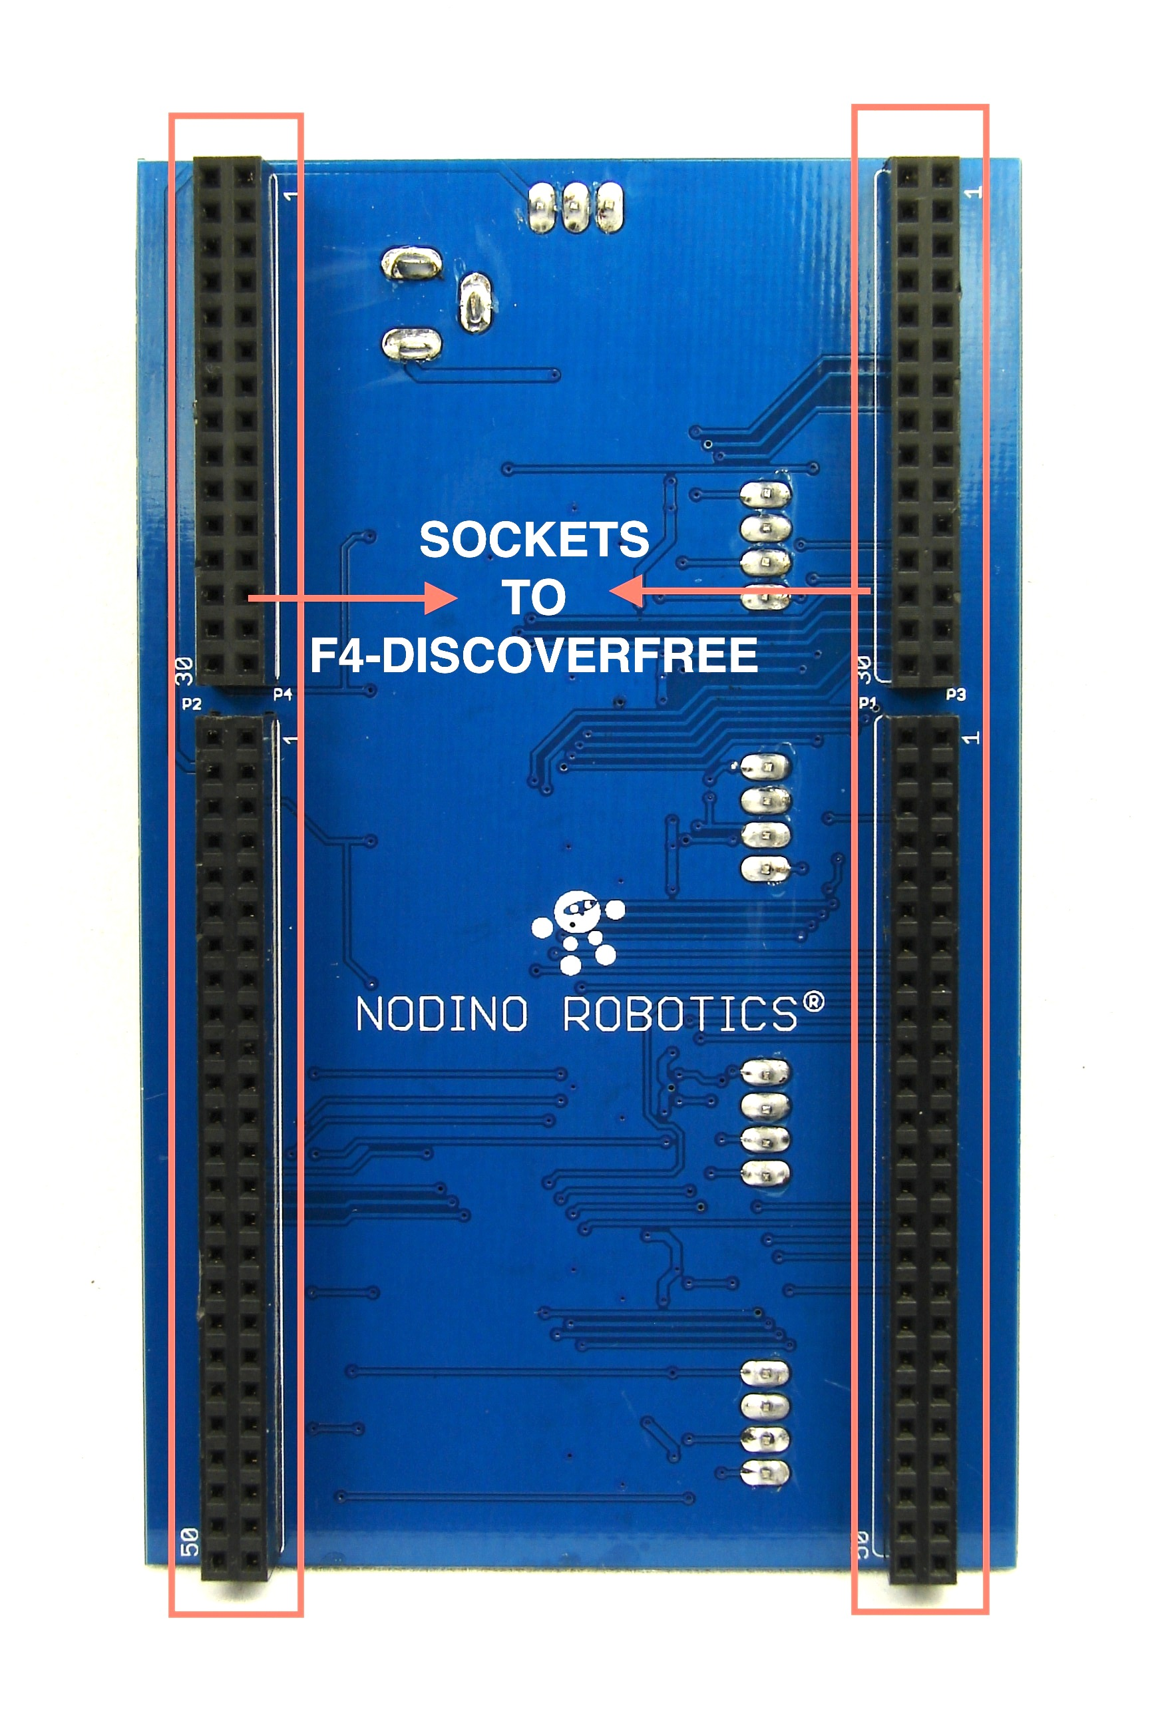Illustration 4: BLDC-MEB bottom component description
- At the bottom layer, two lines containing each 2x15 and 2x25 sockets are board interconnection to F4-DiscoverFree board. Please note carefully that the BLDC-MEB is stacked up on the F4-DiscoverFree (NOT FROM THE BOTTOM).

Software Requirements

PC Software
There is no particular PC Software provided with BLDC-MEB kit. The only interface you need is a serial terminal. You may choose the terminal program like HyperTerminal, TeraTerm, PuTTY or picocom. The following subsections describe how to setup PuTTY on Windows, Linux and Mac OS X.

PuTTY Setup on Windows
Download the latest version of PuTTY from http://www.chiark.greenend.org.uk/~sgtatham/putty and put it on your Desktop. Double click to start a terminal session.
In the configuration window, choose the connection type as Serial with the speed of 115200, and the port number may vary depending on your Windows setup. Figure 5 is showing an example of PuTTY Session configuration on COM4.
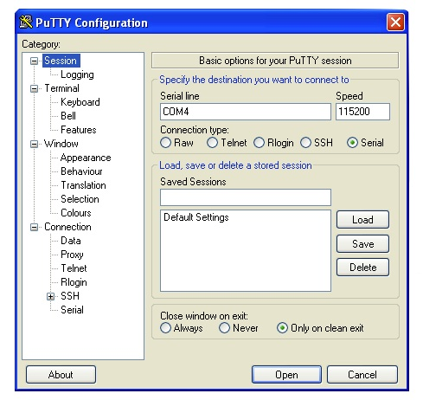Illustration 5: PuTTY Session setting on Windows
Under category on the left side, select Terminal and make sure Implicit CR every LF is ticked. Leave everything else as their default value as illustrated in figure 6.
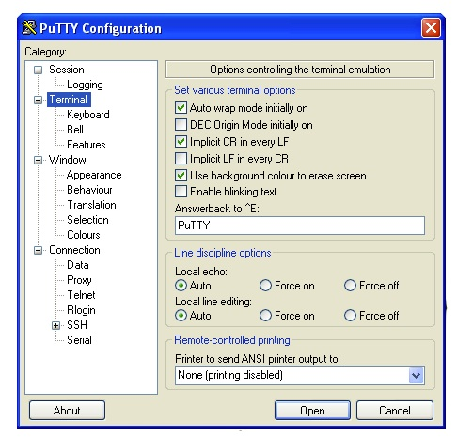Illustration 6: PuTTY Terminal setting on Windows
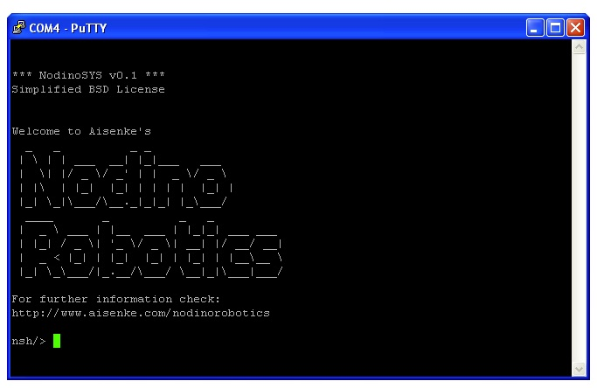Illustration 7: PuTTY Terminal Session is running on Windows
After you are done with the configuration, click Open and the terminal session is running. You may type BLDC commands through terminal.

PuTTY Setup on Ubuntu Linux
To install PuTTY on Ubuntu Linux, go to Synaptic Package Manager and search for PuTTY. Alternatively, you may also open a terminal and type:
sudo apt-get install putty && putty
You need to provide root access to install it.
In the configuration window, choose the connection type as Serial with the speed of 115200, and the device name/number may vary depending on your Linux setup. Figure 8 is showing an example of PuTTY Session configuration on /dev/ttyUSB1 device.
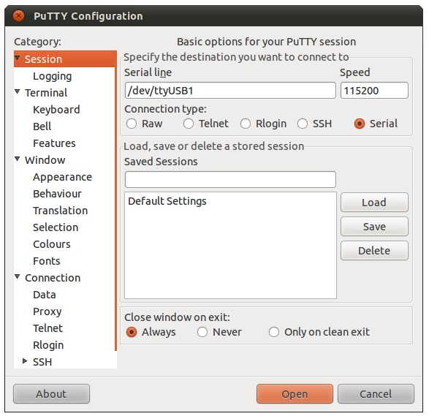Illustration 8: PUTTY Session setting on Linux
Under category on the left side, select Terminal and make sure Implicit CR every LF is ticked. Leave everything else as their default value as illustrated in figure 9.
After you are done with the configuration, click Open and the terminal session is running. You may type BLDC commands through terminal.
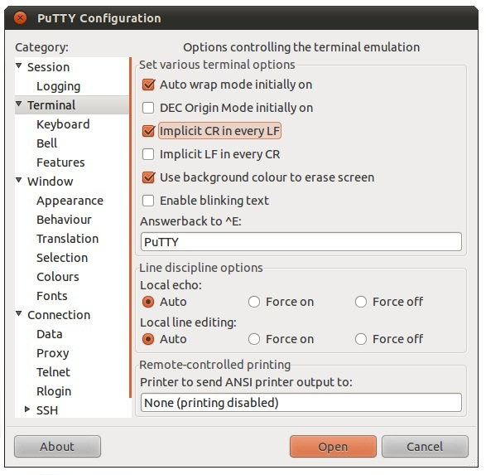Illustration 9: PuTTY Terminal setting on Linux
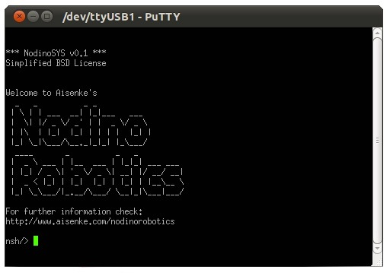Illustration 10: PuTTY Terminal Session is running on Linux

PuTTY Setup on Mac OS X
To install PuTTY on Mac OS X, you need to install macports or brew. Below is an example of installing PuTTY using macports:
sudo port install putty && putty
You need to provide root access to install it.
In the configuration window, choose the connection type as Serial with the speed of 115200, and the device name/number may vary depending on your Mac OS X setup. Figure 11 is showing an example of PuTTY Session configuration on /dev/tty.usbserial-00001004B device.
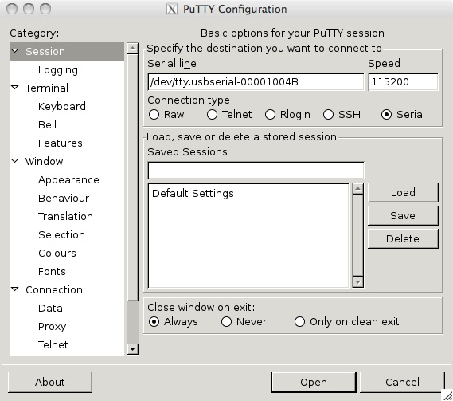Illustration 11: PuTTY Session setting on Mac OS X

Under category on the left side, select Terminal and make sure Implicit CR every LF is ticked. Leave everything else as their default value as illustrated in figure 12.
After you are done with the configuration, click Open and the terminal session is running. You may type BLDC commands through terminal.

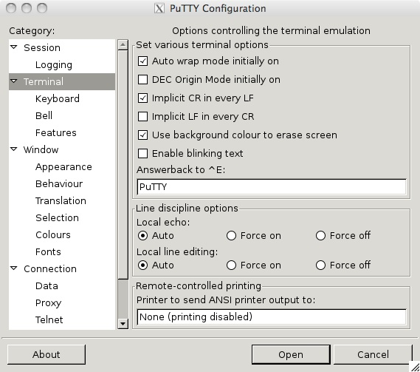Illustration 12: PuTTY Terminal setting on Mac OS X
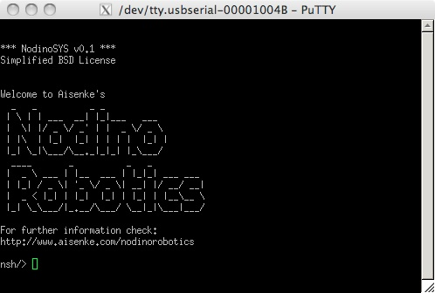Illustration 13: PuTTY Terminal Session is running on Mac OS X

BLDC Firmware
If you purchase the BLDC-MEB bundled with an F4-DiscoverFree, the BLDC firmware is already preinstalled within the F4-DiscoverFree. This firmware is ready to use with any serial terminal.
If you already owned an F4-DiscoverFree and purchase BLDC-MEB separately, then you need to download the firmware from our repository and upload it. You may also want to download the source code if you want to customize to your need. Please refer to F4-DiscoverFree User Manual to update/upload the new firmware and to develop custom application on F4-DiscoverFree.

FTDI Driver
Running serial terminal on Windows might need to download and install FTDI driver chip manually in case the Windows is not able to find it online and install the driver automatically. Please refer to F4-DiscoverFree User Manual on how to do it.
Mac OS X requires you to download and install the driver manually. Please refer to F4-DiscoverFree User Manual.
Linux kernel includes FTDI driver starting from kernel version 2.6.x and later. There is no need to install the driver from FTDI chip.

Hardware References

Jumper SV5
Jumper SV5 by default is put between pin 2 and 3 (or left open) as seen in figure 14. This configuration separates the 5V external power supply from the USB 5V line coming from F4-DiscoverFree board. This is the most recommended configuration to drive BLDC motors with high electrical current (more than 400 mA in total).
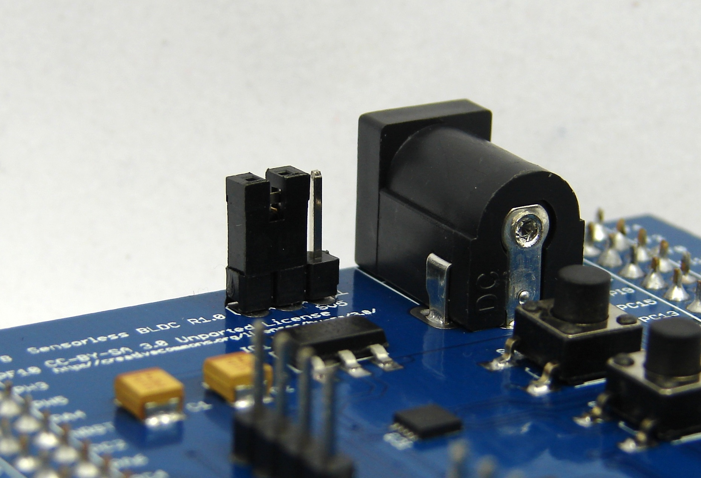Illustration 14: Jumper pin at 2 and 3, separating external power to USB power
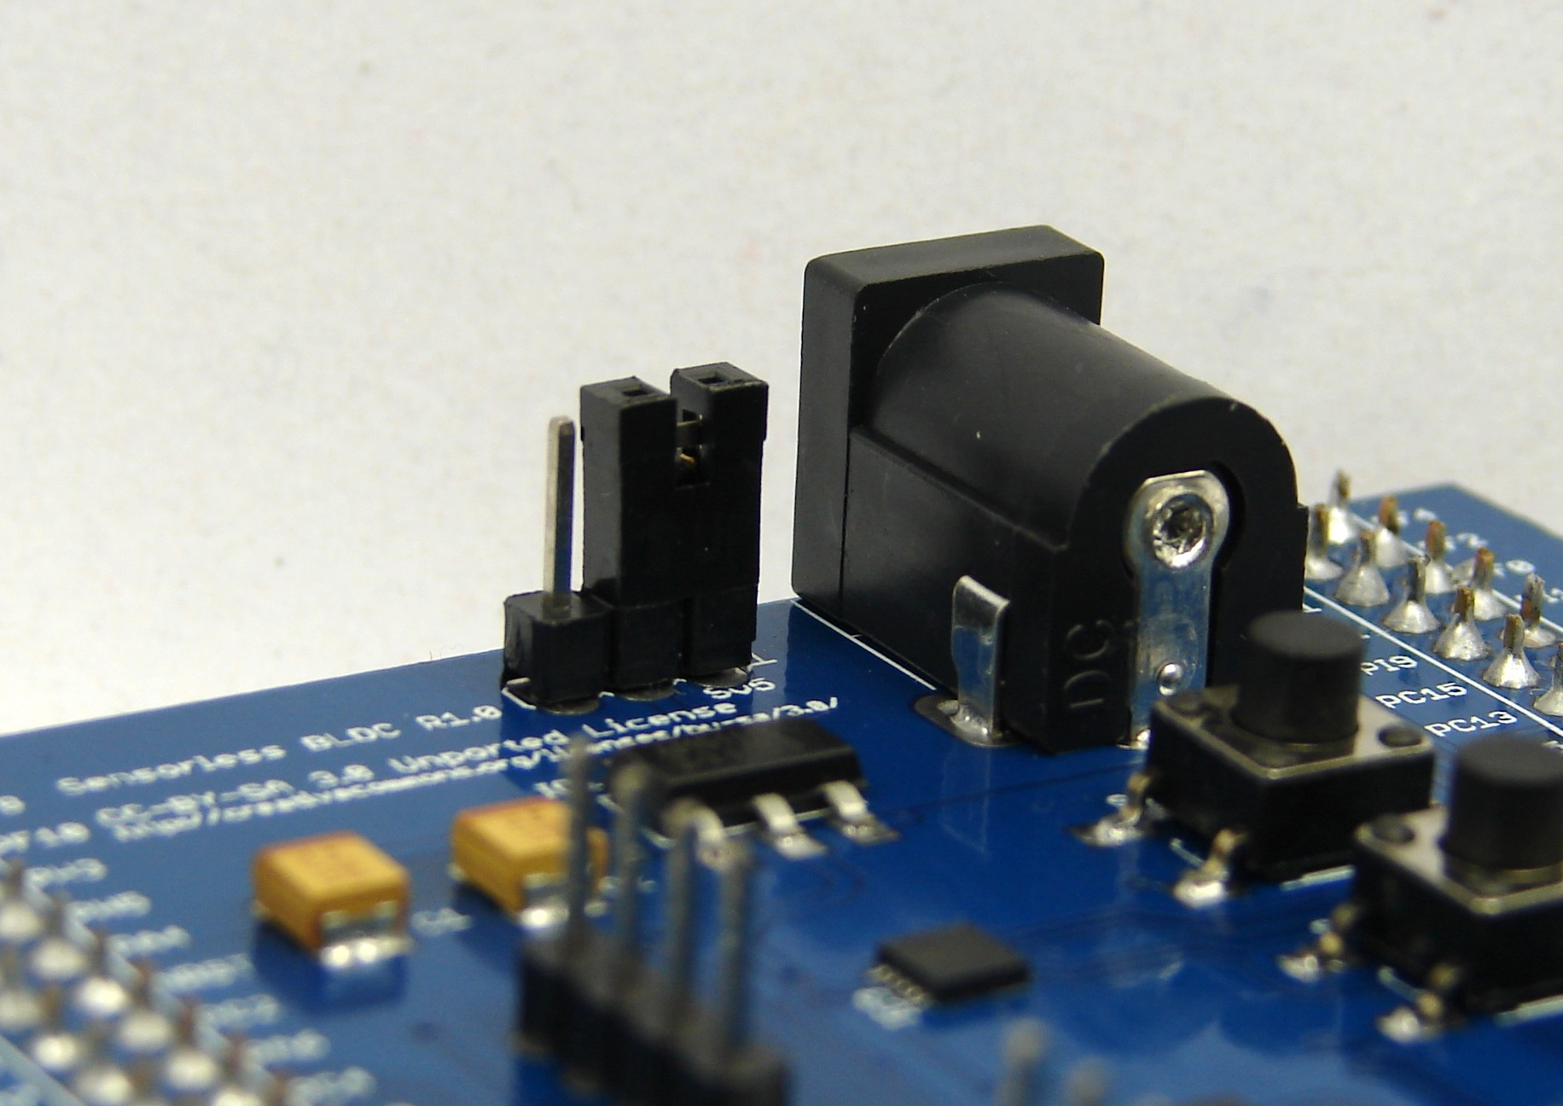Illustration 15: Jumper pin at 1 and 2, combining both external and USB power line
In some cases, you might use micro BLDC motors with less than 400 mA current. This amount of current can be provided by the computer through USB port. If this is the preferable configuration, put the a jumper between pin 1 and 2 as seen on figure 15. This way, the BLDC-MEB and F4-DiscoverFree is supplied through the USB cable. Please do not withdraw more than 500 mA as specified in the USB specification.
Another example where you need this configuration, is when you use the board as a standalone controller utilizing only push buttons. Without the USB cable connected to a computer, you need to power the F4-DiscoverFree from the BLDC-MEB module. Put the jumper between 1 and 2 as seen on figure 15.

DC 5V Socket
The external power supply specification is DC regulated 5V able to deliver at least 2A of electrical current. The standard 2.1mm x 5.5mm male plug should fit in the socket provided on board.
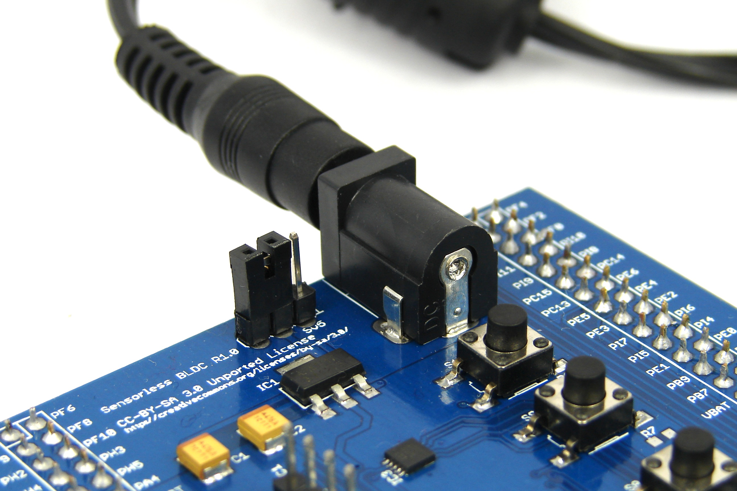Illustration 16: Power supply connected to BLDC-MEB
Please refer to page 17 for the jumper setting in order to separate or combine between external power line to the USB power line.

BLDC Motor Interface
Standard 3-phase BLDC motors have at least 3 pins namely U, V and W. Some type of BLDC motors also provide a neutral pin N as seen in figure 17. BLDC-MEB uses only pin U, V and W to perform sensor-less driving and the neutral pin N is not connected on-board. You may connect it or leave it open on BLDC-MEB.
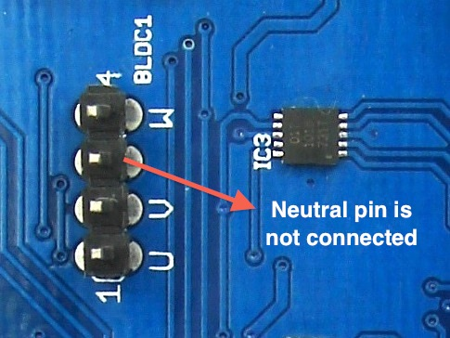Illustration 17: BLDC pins: U, V, N (not used) and W
The header pins are of 2.54 mm pitch and any wiring may suffice to interface to your BLDC motors.

Push Buttons
The default firmware for each BLDC motor assigns a push button depicted in figure 18 at the top as a programmable clockwise button and the other as a programmable counter clockwise button. The term programmable means that each button can be enabled/disabled, toggling between manual or software control.
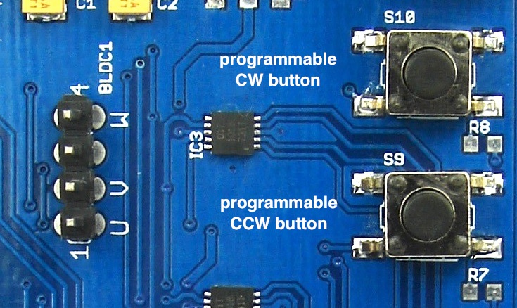Illustration 18: Programmable CW and CCW buttons

Command References
The BLDC application v0.1 firmware introduces three categories of commands:
- Command to change brushless motor properties
- Command to change brushless controller properties
- Command to move brushless motors
To list all of commands available, type:
help bldc
You will get the command listing as seen on figure 19.
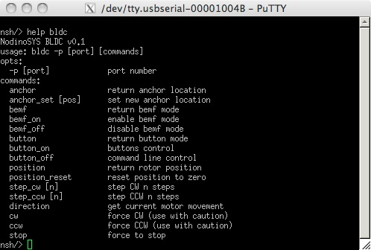Illustration 19: BLDC help screen

Motor Properties

position command
Brushless motor's rotor position is held by position property. The position command is read-only and it returns the current rotor position. This command can be used while the motor is stationary or turning. Example of use:
bldc -p 0 position
> /dev/bldc0 position = 1234

position_reset command
This command resets the rotor position counter to zero. Example of use:
bldc -p 0 position_reset
bldc -p 0 position
> /dev/bldc0 position = 0
It is recommended to use this command only when the motor is stationary. Otherwise, position accuracy cannot be guaranteed.

anchor command
Anchor holds the value of rotor position to which the controller will bring to stop automatically when the current rotor position is equal to anchor value set by anchor_set command. Anchor command is read-only. Example of use:
bldc -p 0 anchor
> /dev/bldc0 anchor = 0

anchor_set command
This command sets a new anchor value at position [pos]. The value can be a negative or positive number. Example of use:
bldc -p 0 anchor_set 1234
bldc -p 0 anchor
> /dev/bldc0 anchor = 1234
Changing anchor value can be done while the motor is stationary or turning. However, please note:
- If the motor is stationary, changing anchor value will not bring the motor to move automatically toward any direction until cw or ccw command is executed.
- If the motor is turning toward CW direction, then setting anchor value to less than the current rotor position will never bring the motor to stop automatically.
- If the motor is turning toward CCW direction, then setting anchor value to greater than the current rotor position will never bring the motor to stop automatically.
The design of brushless controller is always comparing the value of rotor position and its anchor. If both values are the same and the motor is currently turning, the controller immediately brings the motor to a complete stop.

Controller Properties

bemf command
This command is read-only and it returns the current BEMF feedback controller mode enabled/disabled. Return value 1 = BEMF enabled; 0 = BEMF disabled. When BEMF feedback is disabled, the motor moves much slower but the rotor position accuracy can be guaranteed. Example os use:
bldc -p 0 bemf
> /dev/bldc0 bemf mode = 1

bemf_on command
This command is write-only and used to turn BEMF feedback controller mode to ON. Example of use:
bldc -p 0 bemf_on
bldc -p 0 bemf
> /dev/bldc0 bemf mode = 1
Please note that turning on BEMF feedback mode to ON while the motor is turning, will not guarantee rotor position accuracy since miscalculation may occur during mode transition. It is suggested that the motor is always stationary prior to changing BEMF feedback mode.

bemf_off command
This command is write-only and used to turn BEMF feedback controller mode to OFF. Example of use:
bldc -p 0 bemf_off
bldc -p 0 bemf
> /dev/bldc0 bemf mode = 0
Please note that turning off BEMF feedback mode to OFF while the motor is turning, will not take effect immediately. The mode is effective after the motor has stopped.

button command
This command is read-only and it returns the status of button mode enabled/disabled. Return value 1 = button enabled; 0 = button disabled. Example of use:
bldc -p 0 button
> /dev/bldc0 button mode = 1

button_on command
This command is write-only and used to turn button mode to ON. Example of use:
bldc -p 0 button_on
bldc -p 0 button
> /dev/bldc0 button mode = 1
When button is enabled, the motor control priority goes to push buttons. Command line can still be used, but limited to position read/write, anchor read/write, turning on/off BEMF mode and of course turning on/off button mode. The button mode is enabled by default, when the BLDC-MEB is powered up.

button_off command
This command is write-only and used to turn button mode to OFF. Example of use:
bldc -p 0 button_off
bldc -p 0 button
> /dev/bldc0 button mode = 0
When button is disabled, motor control is transferred from push button control to command line control. Buttons cannot be used until they are re-enabled.

BLDC Movement

direction command
This command is read-only and it returns the current motor direction. Return value 1 = turning CW; 0 = stop; -1 = turning CCW. Example of use:
bldc -p 0 direction
> /dev/bldc0 direction = 1

step_cw [n] command
This command turns the motor toward CW direction for [n] steps. Example of use:
bldc -p 0 step_cw 2024
No return result will be given whether the motor stops or currently is moving. You need to poll the motor status by executing direction command. The value n can be a negative or positive number.

step_ccw [n] command
This command turns the motor toward CCW direction for [n] steps. Example of use:
bldc -p 0 step_ccw 2024
No return result will be given whether the motor stops or currently is moving. You need to poll the motor status by executing direction command. The value n can be a negative or positive number.

cw command
This command infinitely turns the motor toward CW direction until stop command is executed or rotor position is equal to anchor value. Example of use:
bldc -p 0 cw

ccw command
This command infinitely turns the motor toward CCW direction until stop command is executed or rotor position is equal to anchor value. Example of use:
bldc -p 0 ccw

stop command
This command immediately stops the motor. A sudden electrical commutation stop will not guarantee that the rotor position remains accurate due to the inertia while it was turning. Use this command as necessary.
We suggest you (whenever possible) to substitute it by combining anchor_set to cw or ccw commands; step_cw or step_ccw which include built-in braking algorithm. Example of use:
bldc -p 0 stop

Schematic
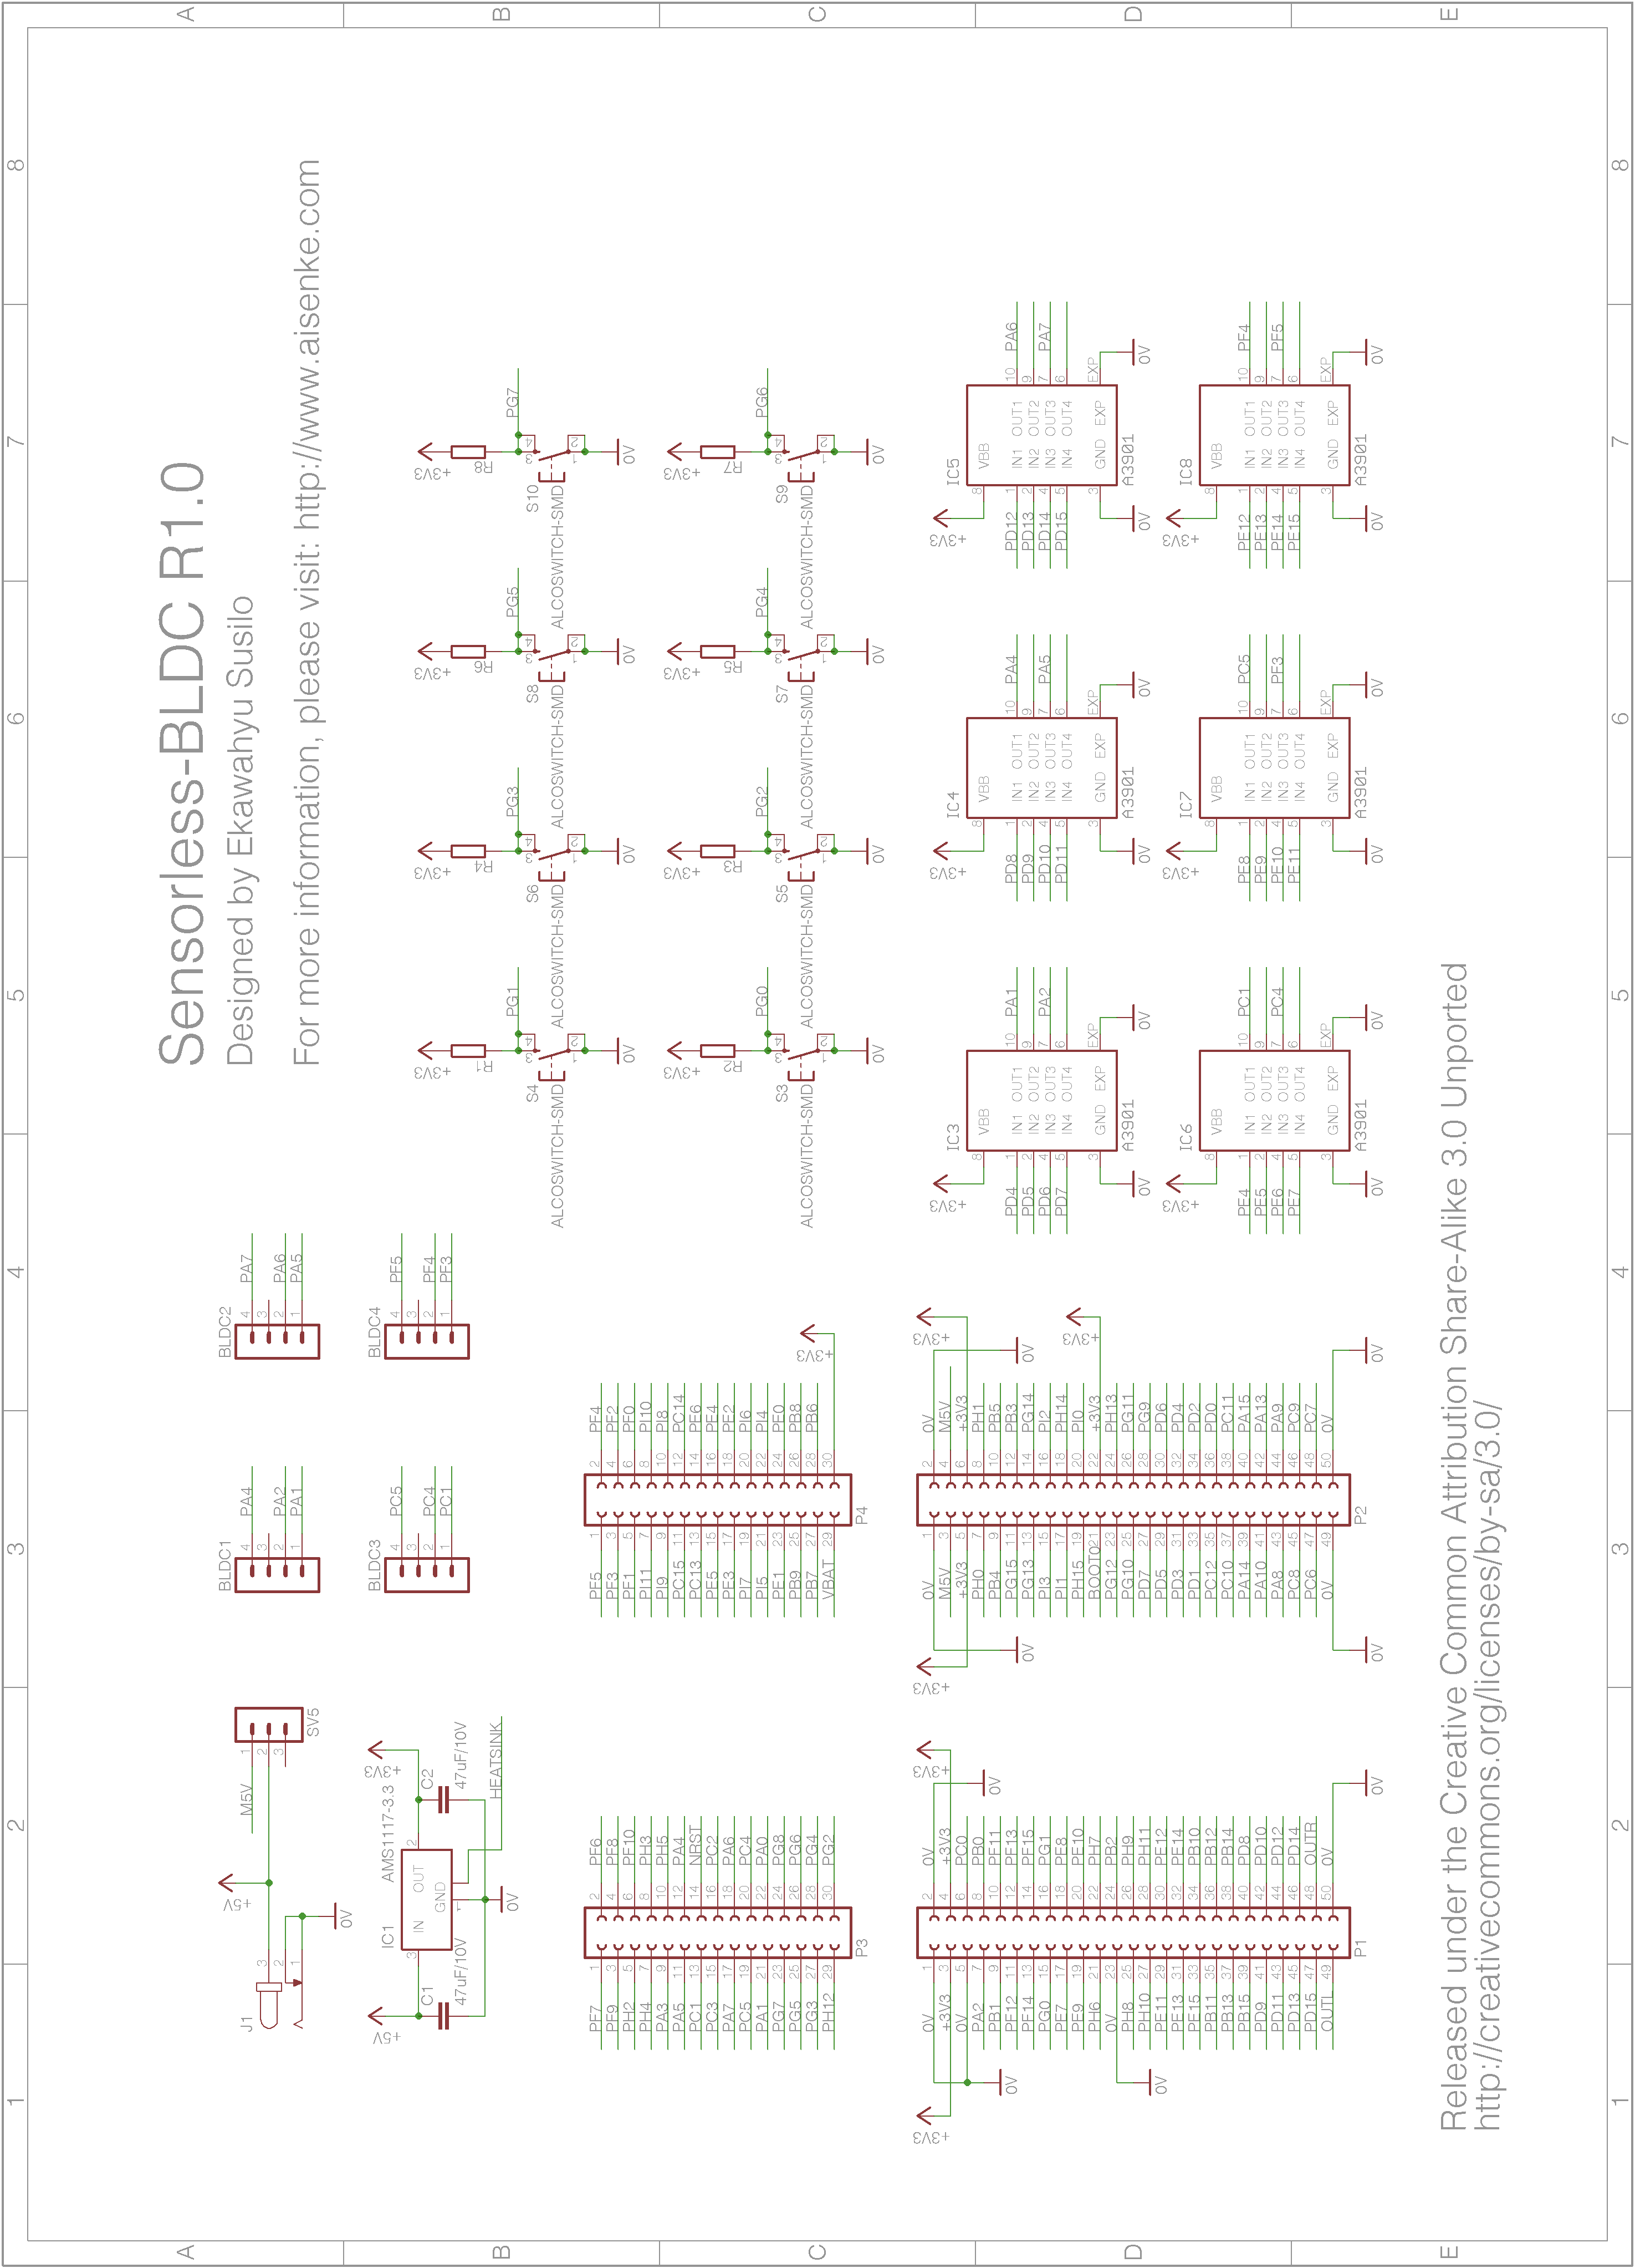Illustration 20: BLDC-MEB Schematic

Revision History
Date | Revision | Changes
29 Jan 2013 | 1 | Initial document release
02/17/13 | 1.1 | Correcting BLDC-MEB board release version
Table 1: Revision history

